- Find the second largest element in an array

#include<stdio.h>
int main() {
int n , i , j ;
printf("Enter Your Array Size : ") ;
scanf("%d" , &n ) ;
int arr[n] ;

// Dynamic array
for( i = 0 ; i < n ; i++ ) {
printf("Enter Value of a[%d] :- " , i ) ;
scanf("%d" , &arr[i] ) ;
}

// Bubble Short
for( i = 0 ; i < n-1 ; i++ ) {
for( j = 0 ; j < n-i-1 ; j++ ) {
if(arr[j]<arr[j+1]) {
arr[j] = arr[j]*arr[j+1];
arr[j+1] = arr[j]/arr[j+1];
arr[j] = arr[j]/arr[j+1];
}
}
}
// Print Second Largest Element

printf("\nSecond Largest Element is %d " , arr[1]);
return 0;
}

Output :

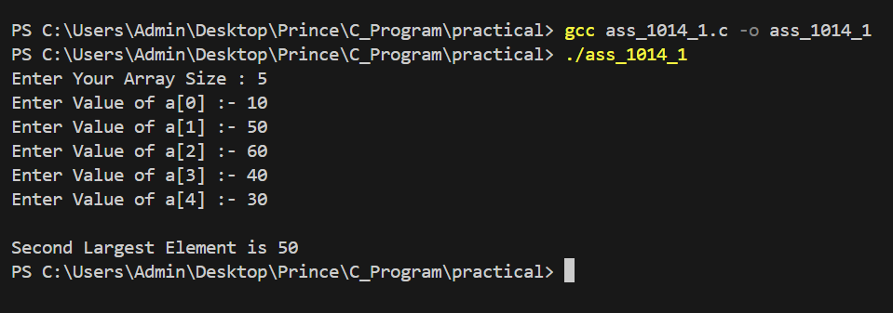

- Reverse a given string

#include<stdio.h>
int main() {
char str[100] ;
int len = 0 ;
printf("Enter a String : ");
fgets( str , sizeof(str) , stdin );

// Count Length of the String
for( int i = 0 ; str[i] != '\0' ; i++ ) {
len++ ;
}
len-- ; // Know Orijinal langth without '\0'

// Print Reverse string Character by Character
for( int j = len ; str[j] >= 0 ; j-- ) {
printf("%c",str[j]);
}
return 0;
}

Output :

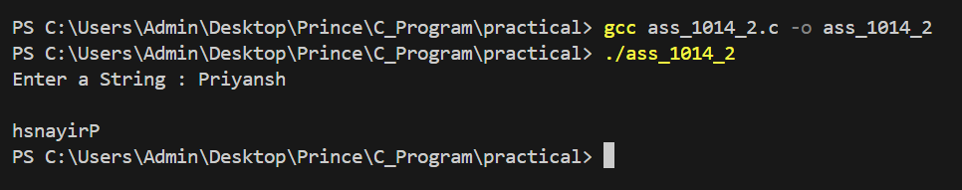

- Find the largest of four numbers

#include<stdio.h>
int main() {
int arr[4] , i ;

//Dynamic Array
for( i = 0 ; i < 4 ; i++ ) {
printf("Enter a arr[%d] : ",i);
scanf("%d",&arr[i]);
}

int large = arr[0] ; // Assumed First Element is Largest
for( i = 1 ; i < 4 ; i++ ) {
if(large < arr[i] ) {
large = arr[i] ;
}
}

printf("Large is : %d " , large );
return 0;
}

Output :

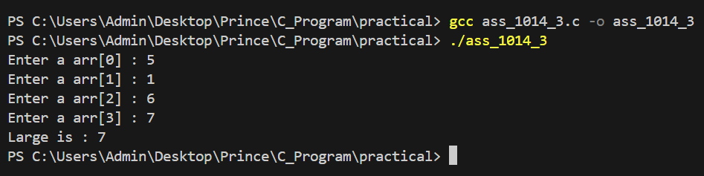

- Print the first N even numbers

#include<stdio.h>
int main() {
int n , i ;
printf("Enter a Number : ");
scanf("%d", &n );
printf("First %d Even Numbers Are : " , n );
for( i = 0 ; i < n ; i++ ) {
printf("%d " , i * 2 );
}
return 0;
}

Output :

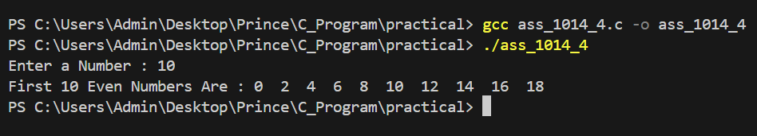

- Subtract two matrices

#include<stdio.h>
int main() {
int r , c , i , j ;
int matrix1[100][100] , matrix2[100][100] , sub[100][100] ;
printf("Enter Row : ") ;
scanf("%d" , &r );
printf("Enter Column : ");
scanf("%d" , &c );

printf("\n");
printf("Value of matrix 1 : \n");

for( i = 0 ; i < r ; i++ ) {
for( j = 0 ; j < c ; j++ ) {
printf("matrix1[%d][%d] : " , i , j );
scanf("%d" , &matrix1[i][j] );
}
}

printf("\n");
printf("Value of matrix 2 : \n");

for( i = 0 ; i < r ; i++ ) {
for( j = 0 ; j < c ; j++ ) {

printf("matrix2[%d][%d] : " , i , j );
scanf("%d" , &matrix2[i][j] );
}
}

for( i = 0 ; i < r ; i++ ) {
for( j = 0 ; j < c ; j++ ) {
sub[i][j] = matrix1[i][j] - matrix2[i][j] ;
}
}

printf("\n");
printf("matrix 1 : \n");

for( i = 0 ; i < r ; i++ ) {
for( j = 0 ; j < c ; j++ ) {
printf("%d\t" , matrix1[i][j] );
}
printf("\n");
}

printf("\n");
printf("matrix 2 : \n");

for( i = 0 ; i < r ; i++ ) {
for( j = 0 ; j < c ; j++ ) {
printf("%d\t" , matrix2[i][j] );
}
printf("\n");
}

printf("\n");
printf("Substraction : \n");

for( i = 0 ; i < r ; i++ ) {
for( j = 0 ; j < c ; j++ ) {
printf("%d\t" , sub[i][j] );
}
printf("\n");
}
return 0;
}

Output :

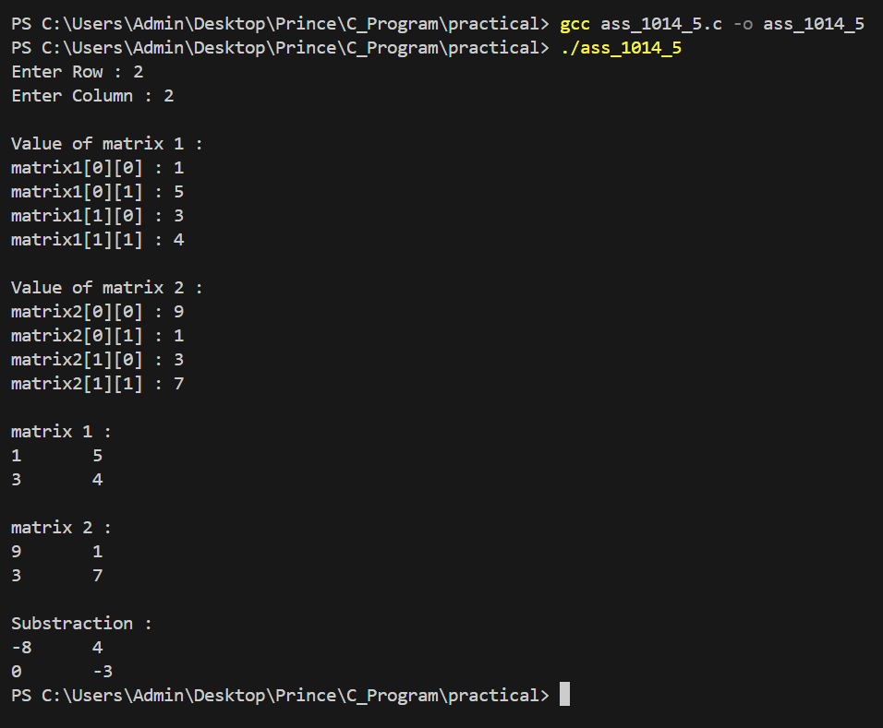

- Check whether a number is perfect

#include <stdio.h>
int main() {
int num , sum = 0 ;
printf("Enter a number: ");
scanf("%d", &num);

for (int i = 1; i <= num / 2; i++) {
if (num % i == 0) {
sum += i;
}
}

if ( sum == num ) {
printf("%d is a perfect number.\n", num);
}
else {
printf("%d is not a perfect number.\n", num);
}

return 0;
}

Output :

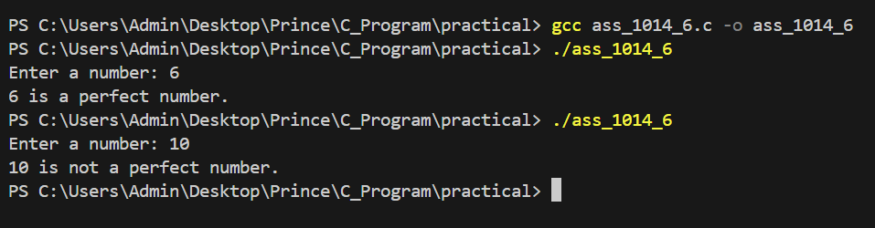

- Count vowels in a string

#include<stdio.h>
int main() {
char str[1000] ;
int vowel = 0 ;
printf("Enter Your String : ");
fgets( str , sizeof ( str ) , stdin );

for ( int i = 0 ; str[i] != '\0' ; i++ ) {
if( str[i] == 'A' || str[i] == 'E' || str[i] == 'I' || str[i] == 'O' || str[i] == 'U' || str[i] == 'a' || str[i] == 'e' || str[i] == 'i' || str[i] == 'o' || str[i] == 'u' ) {
vowel++ ; // if condition is true then vowel increase by 1
}
}
printf("There are %d Vowels in %s " , vowel , str );
return 0;
}

Output :

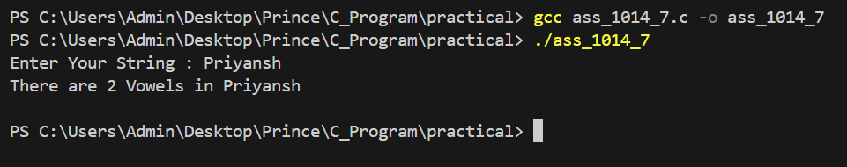

- Calculate the circumference of a circle

#include<stdio.h>
#define pi 3.14 // Constant Declare
int main() {
float r ;
printf("Enter Radius : ");
scanf("%f" , &r );
printf("Circumference of a Circle is %f " , 2*pi*r); // Calculate and Print Circumference of a Circle
return 0;
}

Output :

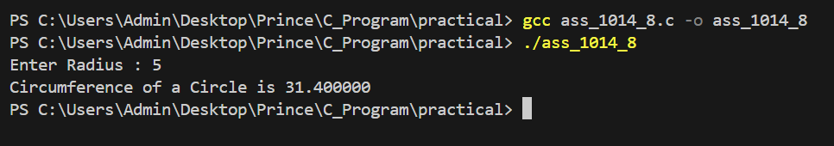

- Delete an element from an array

#include<stdio.h>
int main() {
int size , pos , i ;
printf("Enter Array size : ");
scanf("%d" , &size);
int arr[size] ;
for( i = 0 ; i < size ; i++ ) {
printf("Enter arr[%d] : " , i );
scanf("%d" , &arr[i] );
}
printf("Which Index Number You Have To Delete ( 0 - %d ) : " , size-1 );
scanf("%d" , &pos );
for( i = pos ; i < size ; i++ ) {
arr[i] = arr[i+1] ; // Shift Element Left
}
size-- ; // Reduce Array Size
// Print New Array
printf("Array after Deletion : ");
for ( i = 0 ; i < size ; i++ ) {
printf("%d " , arr[i] );
}
return 0;
}

Output :

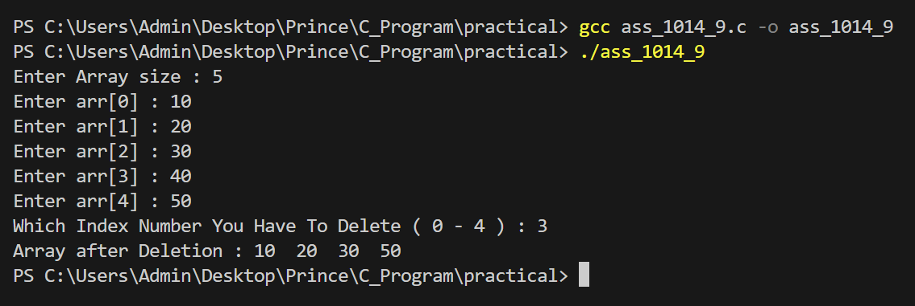

- Convert a string to lowercase

#include<stdio.h>
int main() {
char str[1000] ;
printf("Enter a Strting : ");
fgets( str , sizeof(str) , stdin );
for ( int i = 0 ; str[i] != '\0'; i++ ) {
if( str[i] >= 'A' && str[i] <= 'Z' ) {
str[i] += 32 ;
}
}
printf("Lower String : %s " , str);
return 0;
}

Output :

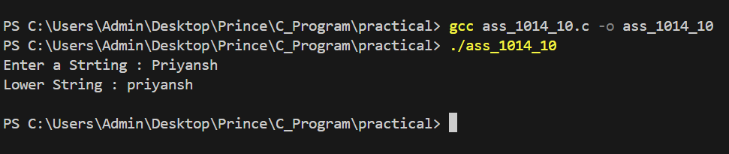

- Search for an element in an array

#include<stdio.h>
int main() {
int size , i , find , a ;
printf("Enter Array Size : ");
scanf("%d" , &size );
int arr[size] ;
for ( i = 0 ; i < size ; i++ ) {
printf("Enter arr[%d] : " , i );
scanf("%d" , &arr[i] );
}
printf("Which Element You Have To Find : ") ;
scanf("%d" , &find );
for ( i = 0 ; i < size ; i++ ) {
if( find == arr[i] ) {
printf("%d is Available on Index of %d \n" , find , i );
a++ ;
}
}
if( !a ) {
printf("%d is not Found " , find );
}
return 0;
}

Output :

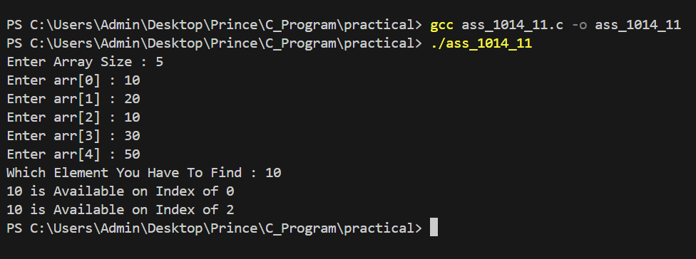

- Check whether a number is prime

#include<stdio.h>
int main() {
int n , prime = 0 ;
printf("Enter a value : ");
scanf("%d" , &n );
for ( int i = 1 ; i <= n ; i++ ) {
if ( n % i == 0 ) {
prime++ ;
}
}
if ( prime == 2 ) {
printf("%d is Prime Number " , n);
}
else {
printf("%d is Non - Prime Number " , n);
}
return 0;
}

Output :

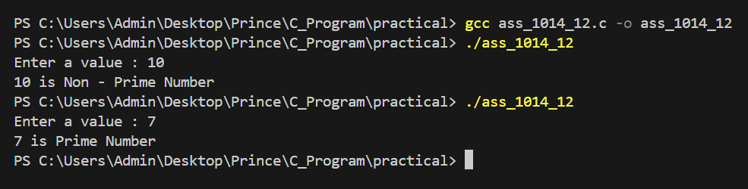

- Add two matrices

#include<stdio.h>
int main() {
int r , c . i , j ;
int matrix1[100][100] , matrix2[100][100] , add[100][100] ;
printf("Enter Row : ") ;
scanf("%d",&r);
printf("Enter Column : ");
scanf("%d",&c);

printf("\n");
printf("Value of matrix 1 : \n");

for( i = 0 ; i < r ; i++ ) {
for( j = 0 ; j < c ; j++ ) {
printf("matrix1[%d][%d] : " , i , j );
scanf("%d" , &matrix1[i][j]);
}
}

printf("\n");
printf("Value of matrix 2 : \n");

for( i = 0 ; i < r ; i++ ) {
for( j = 0 ; j < c ; j++ ) {
printf("matrix2[%d][%d] : " , i , j );
scanf("%d" , &matrix2[i][j]);
}
}

for( i = 0 ; i < r ; i++ ) {
for( j = 0 ; j < c ; j++ ) {
add[i][j] = matrix1[i][j] + matrix2[i][j] ;
}
}

printf("\n");
printf("matrix 1 : \n");

for( i = 0 ; i < r ; i++ ) {
for( j = 0 ; j < c ; j++ ) {
printf("%d\t",matrix1[i][j]);
}
printf("\n");
}

printf("\n");
printf("matrix 2 : \n");

for( i = 0 ; i < r ; i++ ) {
for( j = 0 ; j < c ; j++ ) {
printf("%d\t",matrix2[i][j]);
}
printf("\n");
}

printf("\n");
printf("Addition : \n");

for( i = 0 ; i < r ; i++ ) {
for( j = 0 ; j < c ; j++ ) {
printf("%d\t",add[i][j]);
}
printf("\n");
}
return 0;
}

Output :

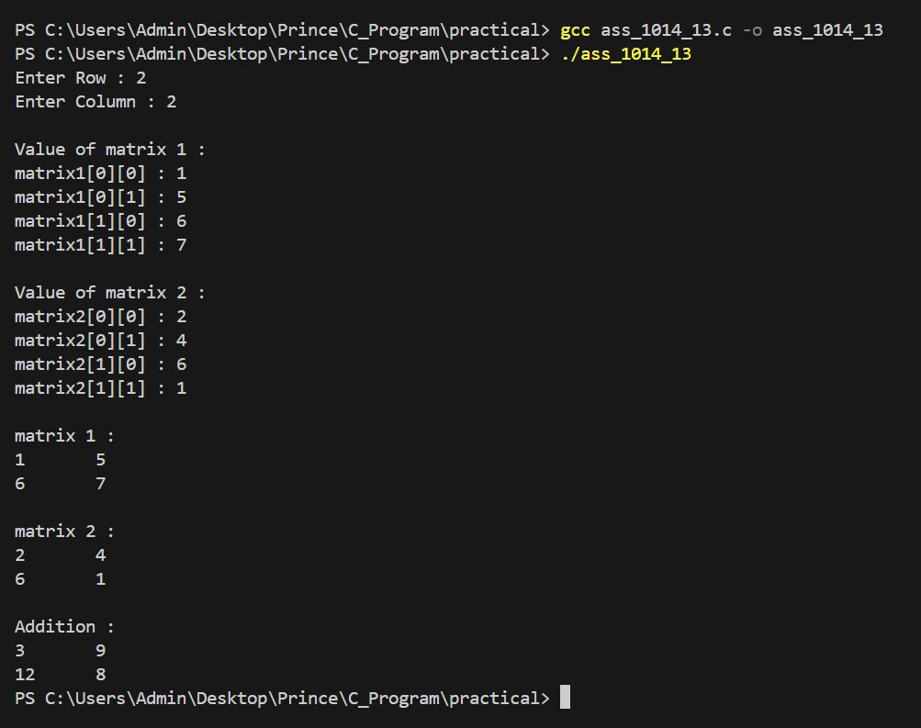

- Count the number of words in a string

#include<stdio.h>
int main() {
char str[1000] ;
int i , count = 0 ;
printf("Enter a String : ");
fgets( str , sizeof(str) , stdin );
for ( i = 0 ; str[i] != '\0' ; i++ ) {
if ( ( str[i] == ' ' || str[i] == '\t' || str[i] == '\n' ) && ( i > 0 && str[i-1] != ' ' && str[i-1] != '\t' && str[i] != '\n' ) ) {
count++ ;
}
}

if( i > 0 && str[i-1] != ' ' && str[i-1] != '\t' && str[i] != '\n' ) {
count++;
}
printf("Number of words : %d " , count);
return 0;
}

Output :

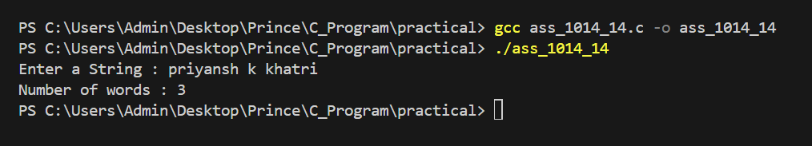

- Multiply two matrices

#include<stdio.h>
int main() {
int r , c , i , j ;
int matrix1[100][100] , matrix2[100][100] , multi[100][100] ;
printf("Enter Row : ") ;
scanf("%d",&r);
printf("Enter Column : ");
scanf("%d",&c);

printf("\n");
printf("Value of matrix 1 : \n");

for( i = 0 ; i < r ; i++ ) {
for( j = 0 ; j < c ; j++ ) {
printf("matrix1[%d][%d] : " , i , j );
scanf("%d" , &matrix1[i][j]);
}
}

printf("\n");
printf("Value of matrix 2 : \n");

for( i = 0 ; i < r ; i++ ) {
for( j = 0 ; j < c ; j++ ) {
printf("matrix2[%d][%d] : " , i , j );
scanf("%d" , &matrix2[i][j]);
}
}

for( i = 0 ; i < r ; i++ ) {
for( j = 0 ; j < c ; j++ ) {
multi[i][j] = matrix1[i][j] * matrix2[i][j] ;
}
}

printf("\n");
printf("matrix 1 : \n");

for( i = 0 ; i < r ; i++ ) {
for( j = 0 ; j < c ; j++ ) {
printf("%d\t",matrix1[i][j]);
}
printf("\n");
}

printf("\n");
printf("matrix 2 : \n");

for( i = 0 ; i < r ; i++ ) {
for( j = 0 ; j < c ; j++ ) {
printf("%d\t",matrix2[i][j]);
}
printf("\n");
}

printf("\n");
printf("Multiplicatin : \n");

for( i = 0 ; i < r ; i++ ) {
for( j = 0 ; j < c ; j++ ) {
printf("%d\t",multi[i][j]);
}
printf("\n");
}
return 0;
}

Output :



